Visualizing Data for Government Officials
Audience: This workshop teaches how to create data displays that are compelling and complete.

Toolkits:
Receive a Student Handbook and Online Toolkit, containing tools such as checklist, tips, techniques, and numerous other tools to help you use your new skills immediately.

Additional Information
CPE Credits: 7.0
CEU Credits: 0.6
Suggested Program Prerequisites: None
Advanced Preparation: Introduction to Analytics for Government Officials
NASBA Program Level: Intermediate
NASBA Field of Study: Specialized Knowledge
Delivery Method: Group Live – Classroom

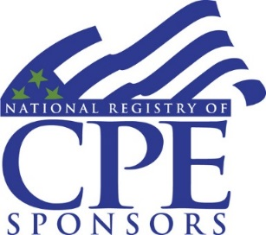

A 1 Day Hands-On TMS Experience

You work data every single day, but no one understands what you’re trying to prove with your tables and graphs. You need better visuals, that create discussions, and enable your leadership to make better decisions. This workshop looks at everything from complex system to simple worksheets and helps you analyze what differentiates a good data display from a bad one.

Course Objectives:

- Defining Your Goal
- What decision are you supporting?
- Who is your audience?
- Single-time graphic, or long-term dashboard?
- What Does Data Say Already?
- Trend analysis and traditional displays
- Binary choice analysis and traditional displays
- Table and Graphic Design
- Simplicity in every line
- Matching visual impact to importance
- Using color and line weighting
- Best practices for table design
- Merging tables, graphs, and text effectively

- Note: This workshop will reference tools found in Microsoft ™ Excel, but all work is done with pen on paper. Steps required to create charts inside the software will be covered by reference.

What to Expect- The TMS Experience

1 Quality Training
INTERACTIVE CLASSROOMS
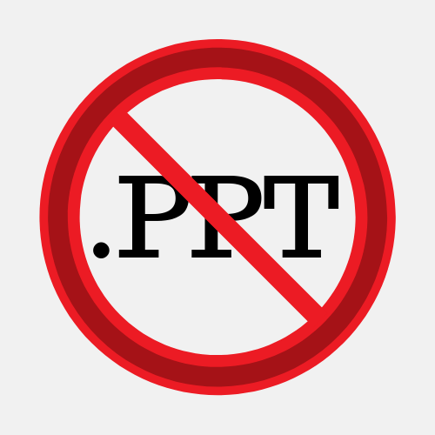
Classroom time is spent on group discussion, case study review, & small group exercises.

Customer-focused and engaging adult learning
instructional techniques, delivered by certified,
experienced, world class instructors.
2 Dynamic Instruction
Classroom emphasis on interactive activities
and no-nonsense pragmatic solutions from
experienced practitioners.
3 Personalized Learning
Student Feedback:

"I have 23 years federal service, this was the best instruction/instructor I’ve ever had the pleasure of meeting!”
- TMS Student, August 2019

“In 35 years of attending training with the government, this is the best format by far.”
- TMS Student, August 2019
We tailor the classroom objectives to the
organization's mission and each participant's
personal professional goals.
4 Ongoing Support
Attendees will receive online toolkits that will
encourage & enable participants to take the
skills and tools they learned in class & apply
them in their workplace.

